Force field mapping

# August 24, 2016

## Meeting notes

* Chris Bayly has a way to automatically find atom types based on SMILES and something similar to SMILES called SMIRKS. He can compare his automatic atom types with atom types in a FF he developed while at Merck (parm@Frosst <http://www.ccl.net/cca/data/parm_at_Frosst/parm_Frosst_note.pdf>) and check for convergence.
* GEM* is a similar attempt to generate a FF from quantum data: <http://pubs.acs.org/doi/full/10.1021/ct500050p>
* McDaniel and Schmidt have a next-generation FF review paper, which seems to focus on using SAPT: <http://www.annualreviews.org/doi/abs/10.1146/annurev-physchem-040215-112047>
* [Regularization](https://en.wikipedia.org/wiki/Regularization_(mathematics)) is a process to help avoid overfitting with parameters. Be cognizant.
* Pure liquid properties we can match (start with the bold):
  + Diffusion
  + **Density**
  + **Enthalpy of vaporization**
  + Dielectric constant
  + Heat capacity
  + Enthalpy of mixing
* The [COBYLA](https://en.wikipedia.org/wiki/COBYLA) optimizer is in [scipy](http://docs.scipy.org/doc/scipy-0.14.0/reference/generated/scipy.optimize.fmin_cobyla.html) and allows constraints on the parameters and does not require the gradient.
* The “[bag of bonds](http://pubs.acs.org/doi/pdf/10.1021/acs.jpclett.5b00831)” model demonstrates a machine learning approach.

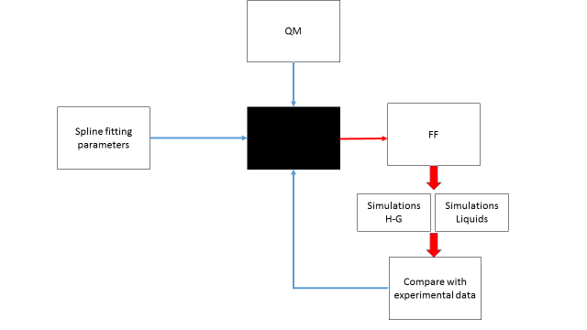

## To-do

1. Write a function to extract relevant properties from simulations.
2. Write a function to output proper parameter and topology files.
3. Write a function to compare computed and experimental properties.
4. Write a function that – for now – loops over values and reports the difference between the chosen parameters and the experimental values.
5. Start with ethanol.